Name :
Hafsa Waseem
Roll no :
Su92-bssem-s24-014
Subject :
Mad (lab)
Submitted to :
Sir Muhammad Abdullah
Task no 5:
Question no 1 :
Main dart :
Code :
import 'package:flutter/material.dart';
import 'login_screen.dart';
import 'signup_screen.dart';
import 'admin_login_screen.dart';
import 'home_screen.dart';
void main() => runApp(MaterialApp(
debugShowCheckedModeBanner: false,
initialRoute: '/',
routes: {
'/': (context) => const SplashScreen(),
'/login': (context) => const LoginScreen(),
'/signup': (context) => const SignUpScreen(),
'/admin': (context) => const AdminLoginScreen(),
'/home': (context) => const HomeScreen(),
},
));
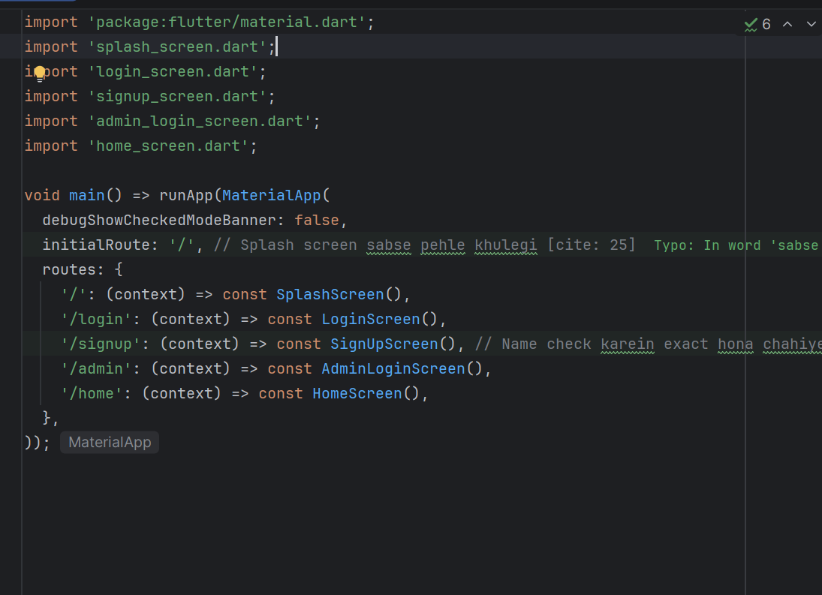
Splash screen:
Code :
import 'dart:async';
import 'package:flutter/material.dart';
class SplashScreen extends StatefulWidget {
const SplashScreen({super.key});
@override
State<SplashScreen> createState() => _SplashScreenState();
}
class _SplashScreenState extends State<SplashScreen> {
@override
void initState() {
super.initState();
Timer(const Duration(seconds: 5), () => Navigator.pushReplacementNamed(context, '/login'));
}
@override
Widget build(BuildContext context) {
return const Scaffold(body: Center(child: Text("SPLASH SCREEN", style: TextStyle(fontSize: 30))));
}
}
output :
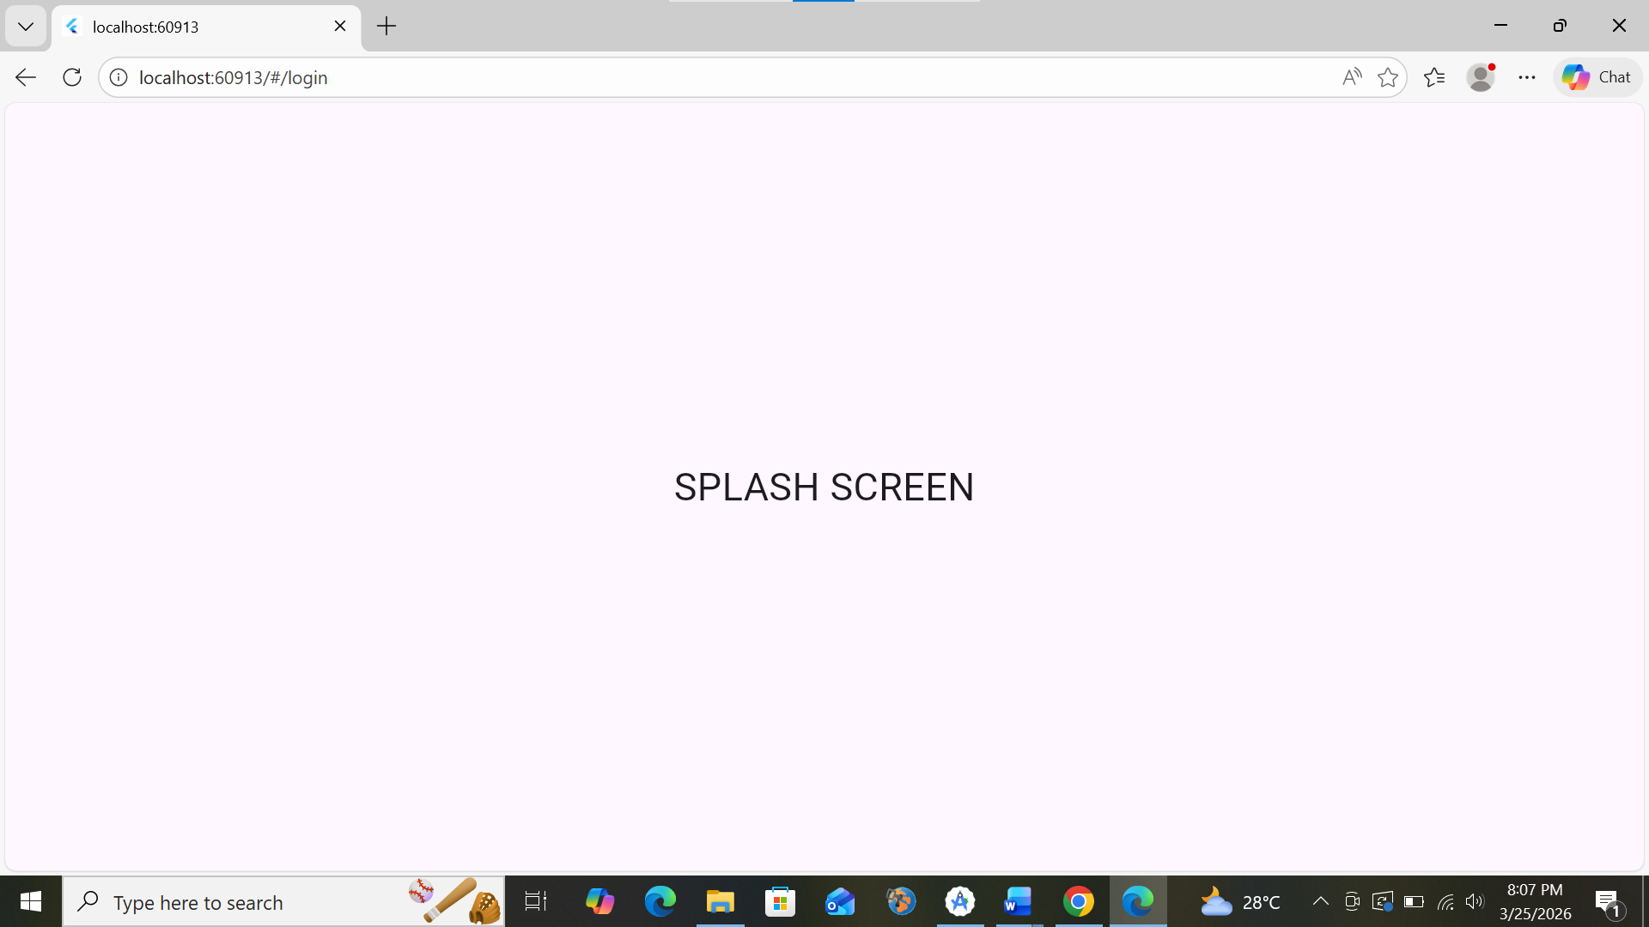
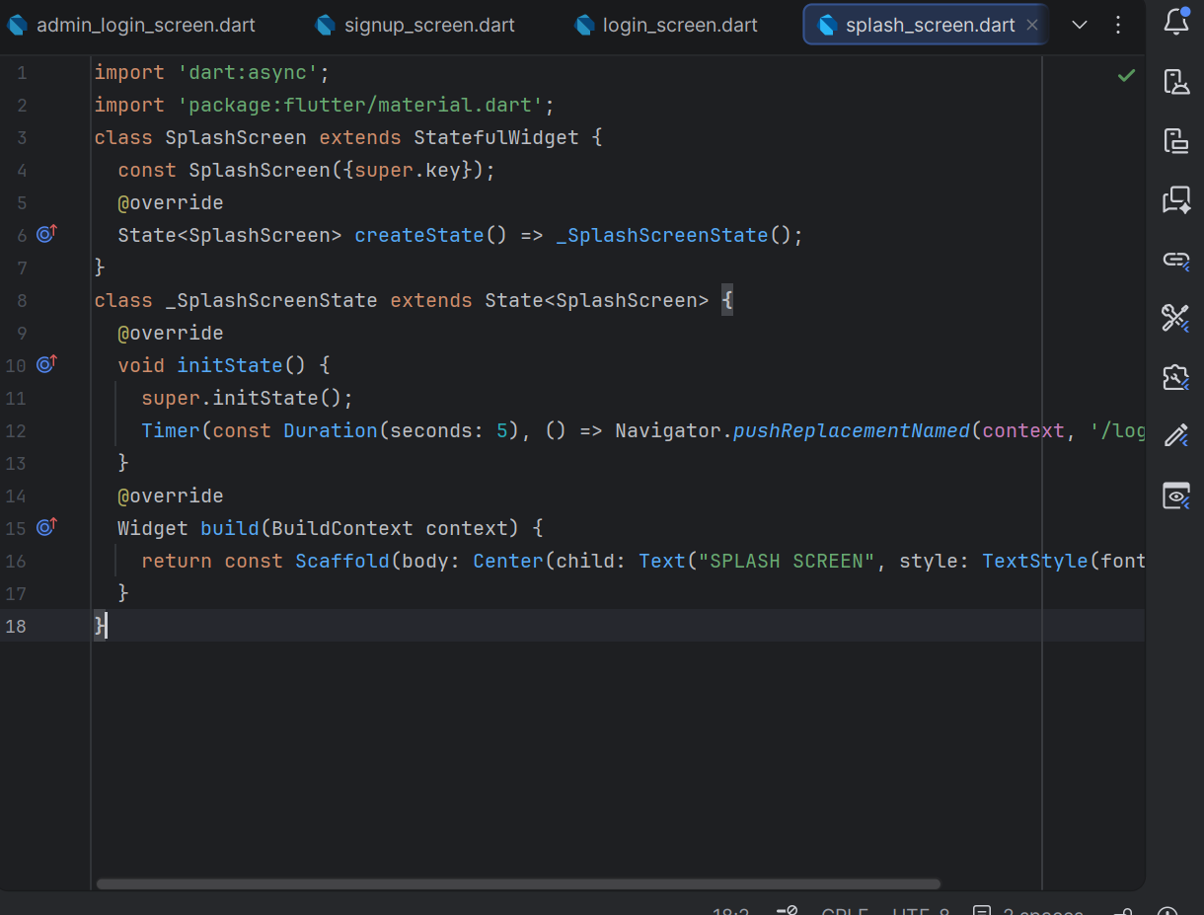
Login screen :
Code :
import 'package:flutter/material.dart';
class LoginScreen extends StatelessWidget {
const LoginScreen({super.key});
@override
Widget build(BuildContext context) {
return Scaffold(
appBar: AppBar(title: const Text("User Login")),
body: Padding(
padding: const EdgeInsets.all(20),
child: Column(children: [
const TextField(decoration: InputDecoration(labelText: "Name")),
const TextField(decoration: InputDecoration(labelText: "Password"), obscureText: true),
ElevatedButton(onPressed: () => Navigator.pushNamed(context, '/home'), child: const Text("Login")),
TextButton(onPressed: () => Navigator.pushNamed(context, '/signup'), child: const Text("Don't have any account? Sign Up")),
TextButton(onPressed: () => Navigator.pushNamed(context, '/admin'), child: const Text("Login as an admin")),
]),
),
);
}
}
output:
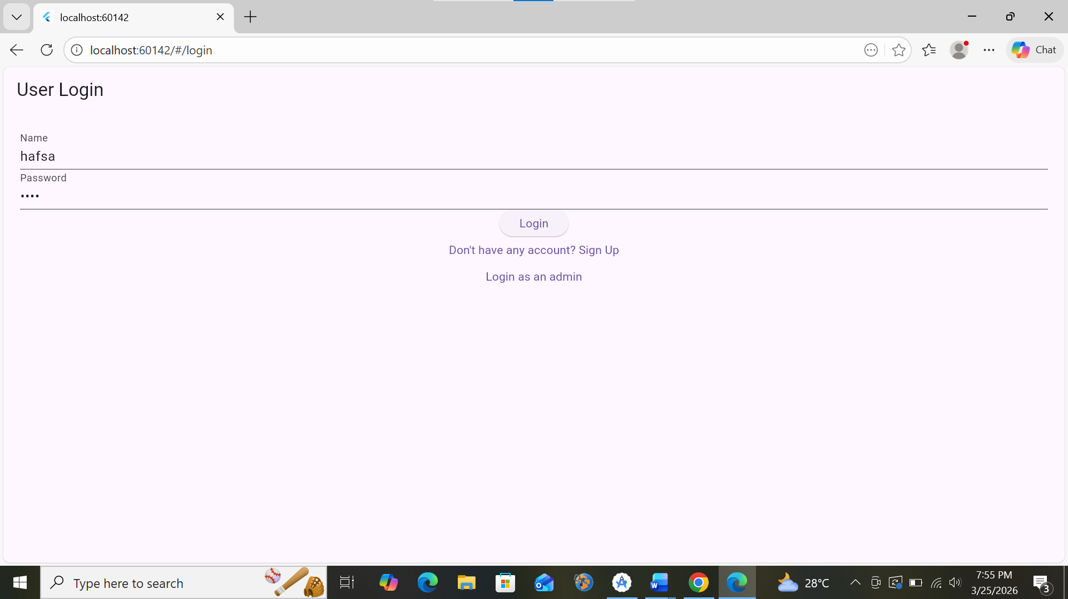
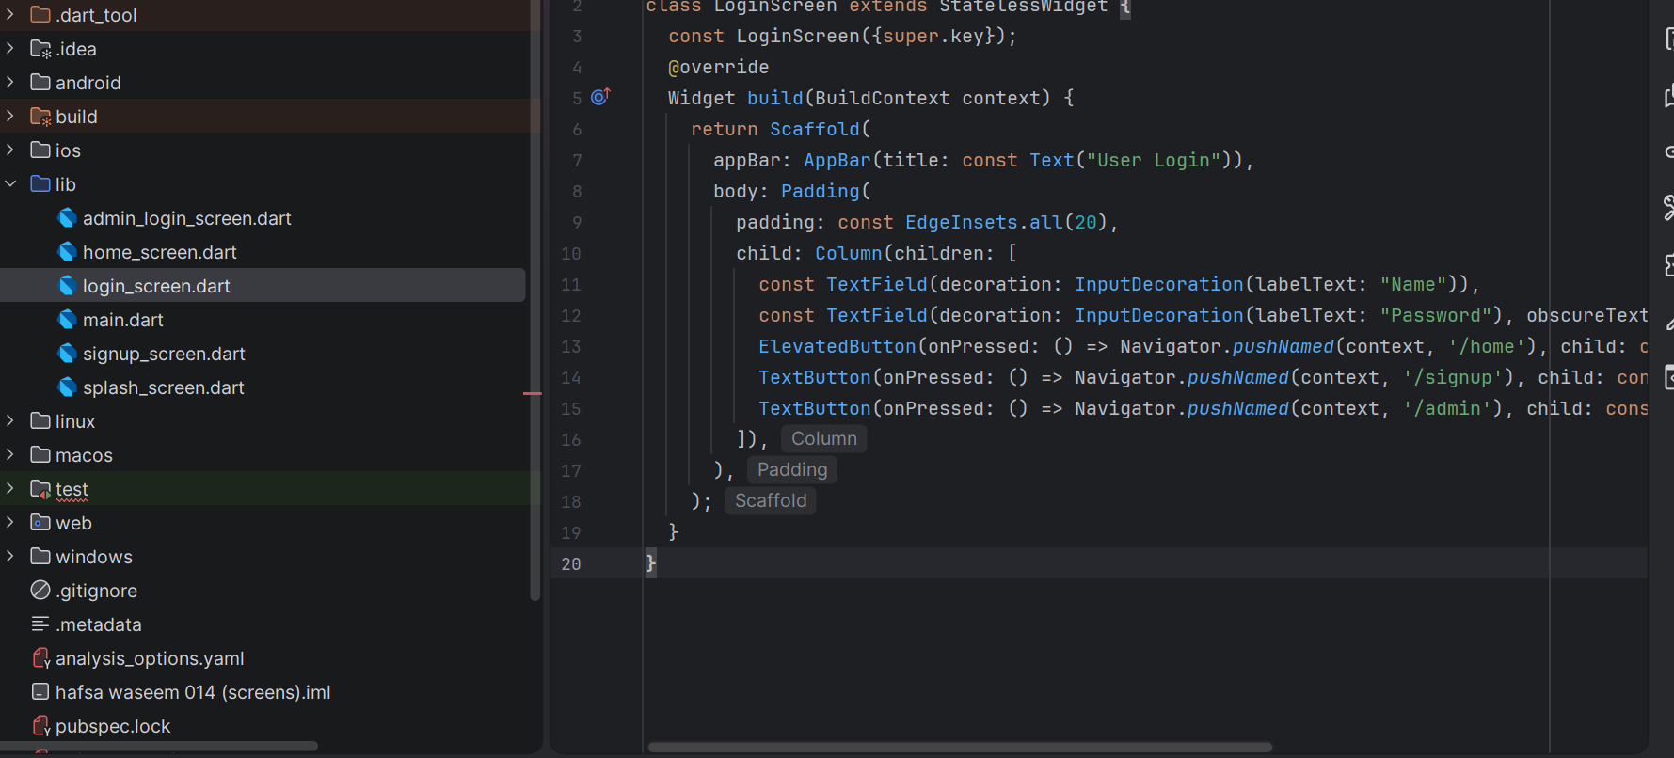
Signup screen :
Code :
class SignUpScreen extends StatelessWidget {
const SignUpScreen({super.key});
@override
Widget build(BuildContext context) {
return Scaffold(
appBar: AppBar(title: const Text("Sign Up")),
body: Padding(
padding: const EdgeInsets.all(20.0),
child: Column(
children: [
const TextField(decoration: InputDecoration(labelText: "Name")),
const TextField(decoration: InputDecoration(labelText: "Password"), obscureText: true),
const SizedBox(height: 20),
ElevatedButton(
onPressed: () => Navigator.pop(context),
child: const Text("Register"),
),
],
),
),
);
}
}
output:
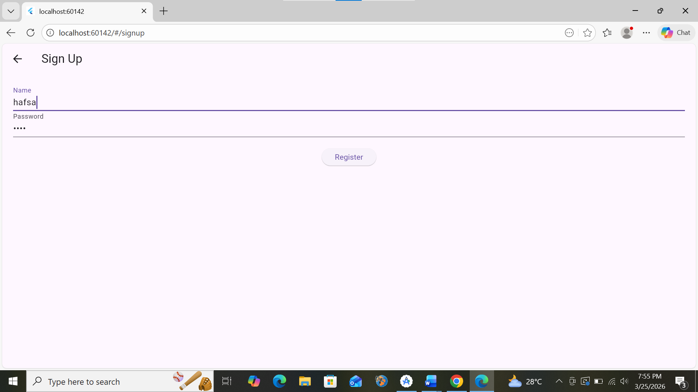
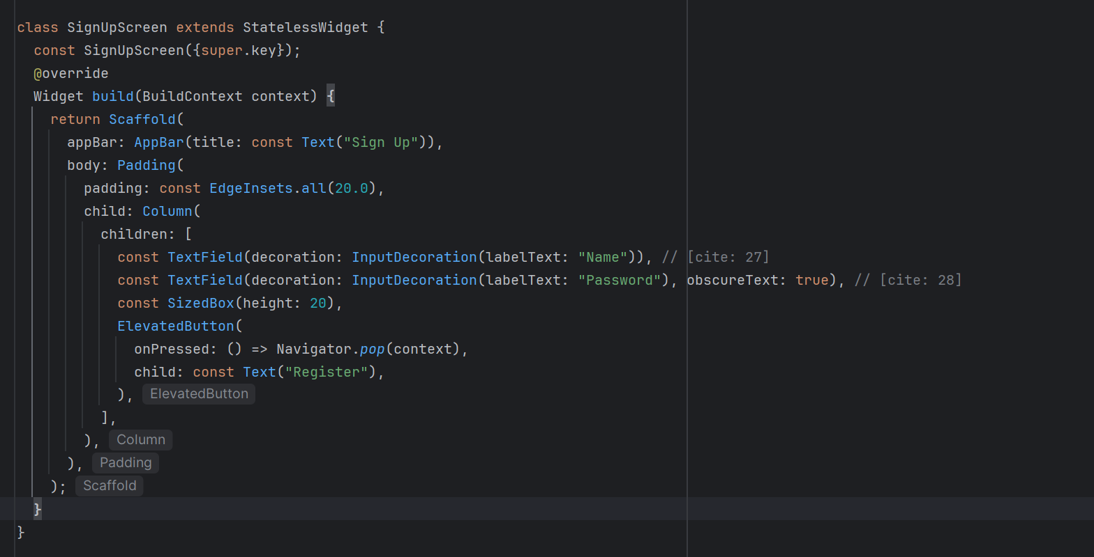
Login as admin :
Code :
import 'package:flutter/material.dart';
class AdminLoginScreen extends StatelessWidget {
const AdminLoginScreen({super.key});
@override
Widget build(BuildContext context) {
return Scaffold(
appBar: AppBar(title: const Text("Admin Login")),
body: Padding(
padding: const EdgeInsets.all(20.0),
child: Column(
mainAxisAlignment: MainAxisAlignment.center,
children: [
const TextField(decoration: InputDecoration(labelText: "Admin Email")),
const TextField(decoration: InputDecoration(labelText: "Admin Password"), obscureText: true),
const SizedBox(height: 20),
ElevatedButton(
onPressed: () => Navigator.pushReplacementNamed(context, '/home'),
child: const Text("Login as Admin"),
),
],
),
),
);
}
}

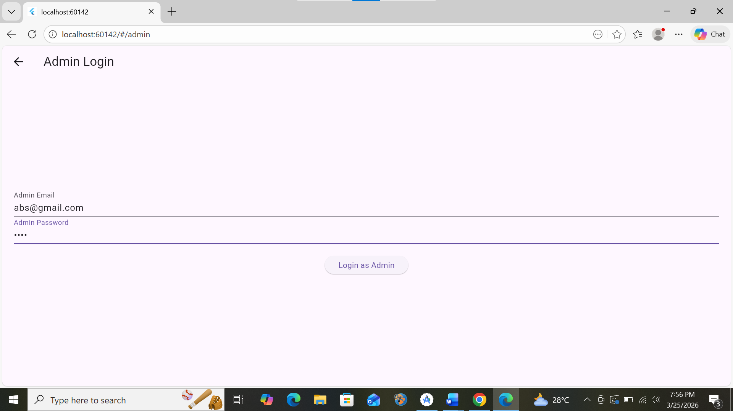
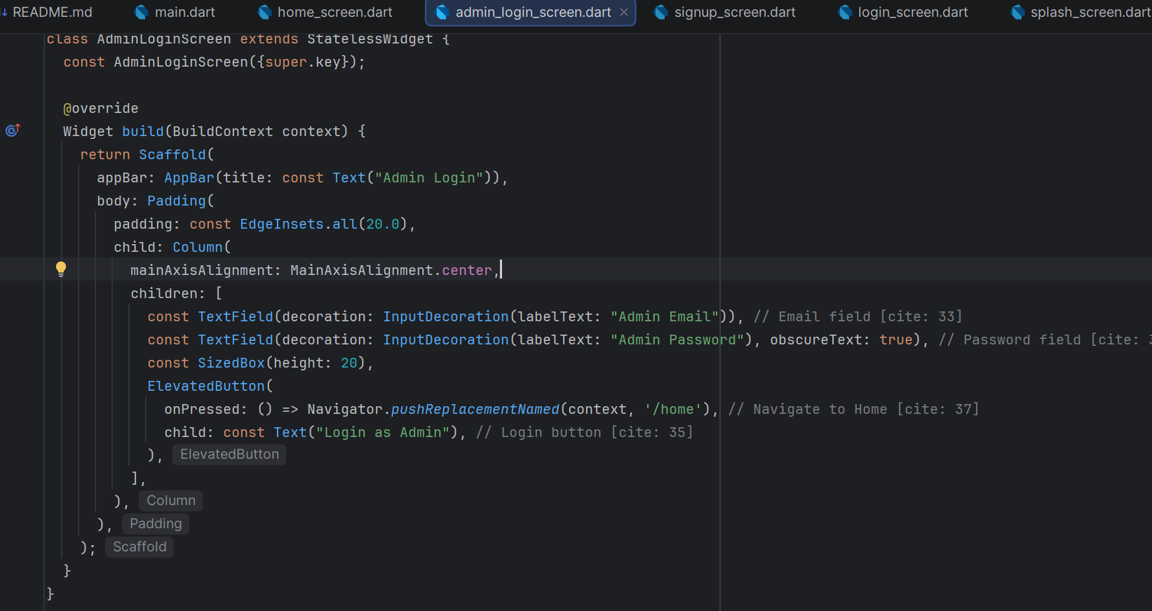

Home screen :
Code :
import 'package:flutter/material.dart';
class HomeScreen extends StatelessWidget {
const HomeScreen({super.key});
@override
Widget build(BuildContext context) {
return Scaffold(
appBar: AppBar(title: const Text("Home Screen")),
body: const Center(child: Text("Welcome to Home")),
bottomNavigationBar: BottomNavigationBar(items: const [
BottomNavigationBarItem(icon: Icon(Icons.home), label: "Home"),
BottomNavigationBarItem(icon: Icon(Icons.person), label: "Profile"),
]),
);
}
}
output :

